Christianity and the Roman Empire - Sources
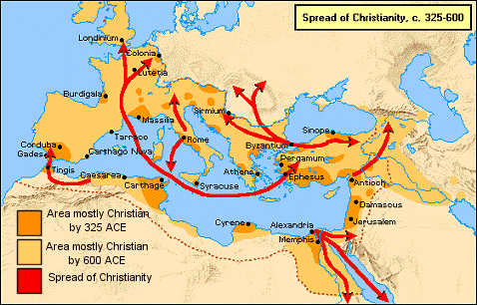
- Christianity and the political authority of Rome:
Matthew 22:15-22
¹⁵ Then the Pharisees (Jewish leaders) went and plotted how to entangle him (Jesus) in his words. ¹⁶ And they sent their disciples to him, along with the Herodians (Roman leaders), saying, “Teacher, we know that you are true and teach the way of God truthfully, and you do not care about anyone's opinion, for you are not swayed by appearances.^{[b]} ¹⁷ Tell us, then, what you think. Is it lawful to pay taxes to Caesar, or not?” ¹⁸ But Jesus, aware of their malice, said, “Why put me to the test, you hypocrites? ¹⁹ Show me the coin for the tax.” And they brought him a denarius.^{[c]} ²⁰ And Jesus said to them, “Whose likeness and inscription is this?” ²¹ They said, “Caesar's.” Then he said to them, “Therefore render to Caesar the things that are Caesar's, and to God the things that are God's.” ²² When they heard it, they marveled. And they left him and went away.

- Christian claims of exclusivity:
John 14:1-7
“Let not your hearts be troubled. Believe in God;^{[a]} believe also in me. ² In my Father's house are many rooms. If it were not so, would I have told you that I go to prepare a place for you?^{[b]} ³ And if I go and prepare a place for you, I will come again and will take you to myself, that where I am you may be also. ⁴ And you know the way to where I am going.”^{[c]} ⁵ Thomas said to him, “Lord, we do not know where you are going. How can we know the way?” ⁶ Jesus said to him, “I am the way, and the truth, and the life. No one comes to the Father except through me. ⁷ If you had known me, you would have known my Father also.^{[d]} From now on you do know him and have seen him.”

- Persecution by Roman Emperors:
Passage from the Annals of Roman Historian Tacitus:
Neither human help, nor imperial munificence, nor all the modes of placating heaven, could stifle scandal or dispel the belief that the fire had taken place by order. Therefore to scotch the rumor, Nero substituted as culprits, and punished with the utmost refinements of cruelty, a class of men, loathed for their vices, whom the crowd styled Christians.
Christus, the founder of the name, had undergone the death penalty in the reign of Tiberius, by sentence of the procurator Pontius Pilatus, and the pernicious superstition was checked for a moment, only to break out once more, not merely in Judea, the home of the disease, but in the capital [Rome] itself, where all things horrible or shameful in the world collect and find a vogue.
First, then, the confessed members of the sect were arrested; next, on their disclosures vast numbers were convicted, not so much on the count of arson as for hatred of the human race. And derision accompanied their end: they were covered with wild beasts' skins and torn to death by dogs; or they were fastened on crosses, and, when daylight failed were burned to serve as lamps by night. Nero had offered his gardens for the spectacle, and gave an exhibition in his Circus, mixing with the crowd in the habit of a charioteer, or mounted on his car. Hence, in spite of a guilt, which had earned the most exemplary punishment, there arose a sentiment of pity, due to the impression that they were being sacrificed not for the welfare of the state but to the ferocity of a single man.

- Christian responses to persecution:
Church Father Justin Martyr on the results of persecution (Dialogue with Trypho the Jew, chapter 110)
Now it is evident that no one can terrify or subdue us who have believed in Jesus over all the world. For it is plain that, though beheaded, and crucified, and thrown to wild beasts, and chains, and fire, and all other kinds of torture, we do not give up our confession; but the more such things happen, the more do others and in larger numbers become faithful, and worshippers of God through the name of Jesus. For just as if one should cut away the fruit-bearing parts of a vine, it grows up again, and yields other branches flourishing and fruitful; even so the same thing happens with us. For the vine planted by God and Christ the Saviour is His people. But the rest of the prophecy shall be fulfilled at His second coming.

